**Northwind Service Steps:**

Destinations are key building blocks in SAP BTP, and are used to define connections for outbound communication from your application to remote systems. These remote systems can be on-premises or in the cloud.

A destination has a name, a URL, authentication details, and some other configuration details.

The destination you will define here is for the set of [OData](http://www.odata.org/) services known as the “Northwind” services, which are publicly available and hosted by OASIS at [https://services.odata.org](https://services.odata.org/).

The Northwind OData services comes in several versions. The tutorials currently use either V2 (<https://services.odata.org/V2/Northwind/Northwind.svc/>) or V4 (<https://services.odata.org/V4/Northwind/Northwind.svc/>). To support both versions, and other versions that may be added later, you will create a generic connection to the Northwind service. The exact path - and exact version - will be configured in later tutorials.

Step 1: Enter your BTP account

Go to [https://account.hanatrial.ondemand.com](https://account.hanatrial.ondemand.com/) or [https://account.hana.ondemand.com](https://account.hana.ondemand.com/) and log in to the SAP BTP cockpit.

Step 2: Access your subaccount

Click on the tile of your Cloud Foundry subaccount.

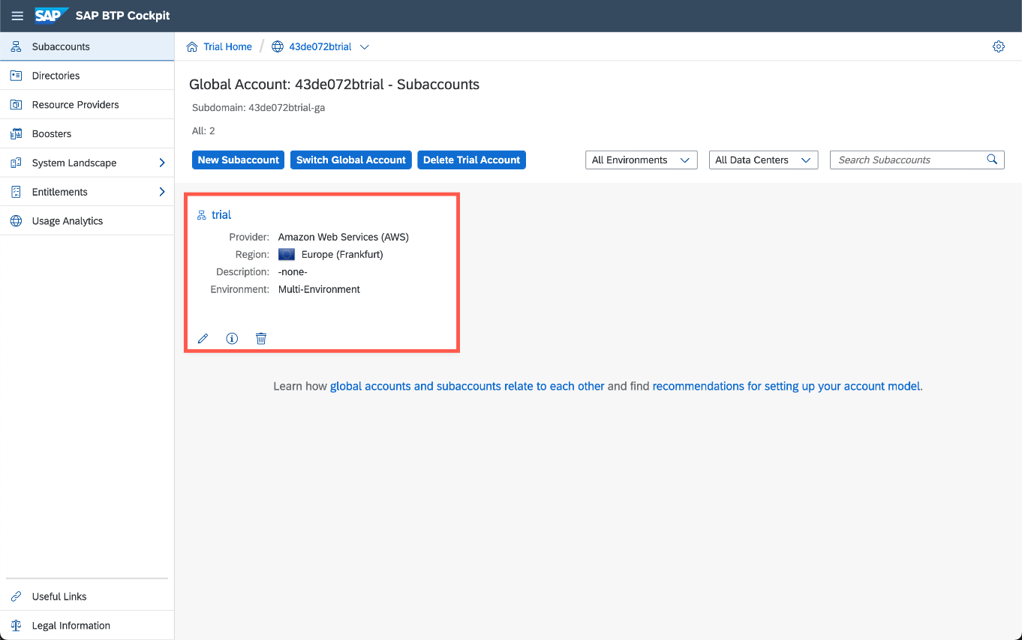

Step 3: Open the Destinations view

Click on the **Destinations** button on the left panel and click **New Destination** to open a new destination configuration form.

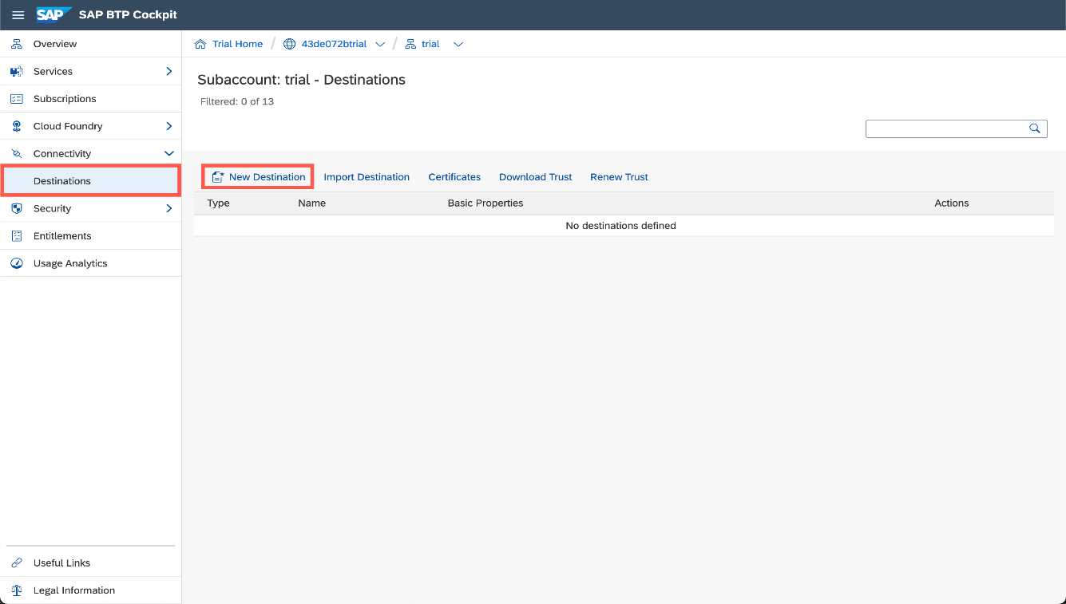

Step 4: Create new destination

Enter/confirm all fields in the destination configuration section with the information below and confirm with **Save**.

| **Field Name** | **Value** |
| --- | --- |
| Name | **Northwind** |
| Type | **HTTP** |
| Description | **Northwind OData services** |
| URL | **https://services.odata.org** |
| Proxy Type | **Internet** |
| Authentication | **NoAuthentication** |

And the following *Additional Properties*

| **Property Name** | **Value** |
| --- | --- |
| HTML5.DynamicDestination | **true** (enter this property manually as it is not available in the dropdown list) |
| WebIDEEnabled | **true** |

Do **not** use the entire path for the URL. The URL should only be https://services.odata.orgYou can find more information on the used properties in the [documentation](https://help.sap.com/viewer/9d1db9835307451daa8c930fbd9ab264/Cloud/en-US/7e49887e6fd34182bebeca5a6841a0cc.html)

When you specify a URL with the HTTPS scheme, a checkbox **Use default JDK truststore** will appear. Ensure that this is checked.

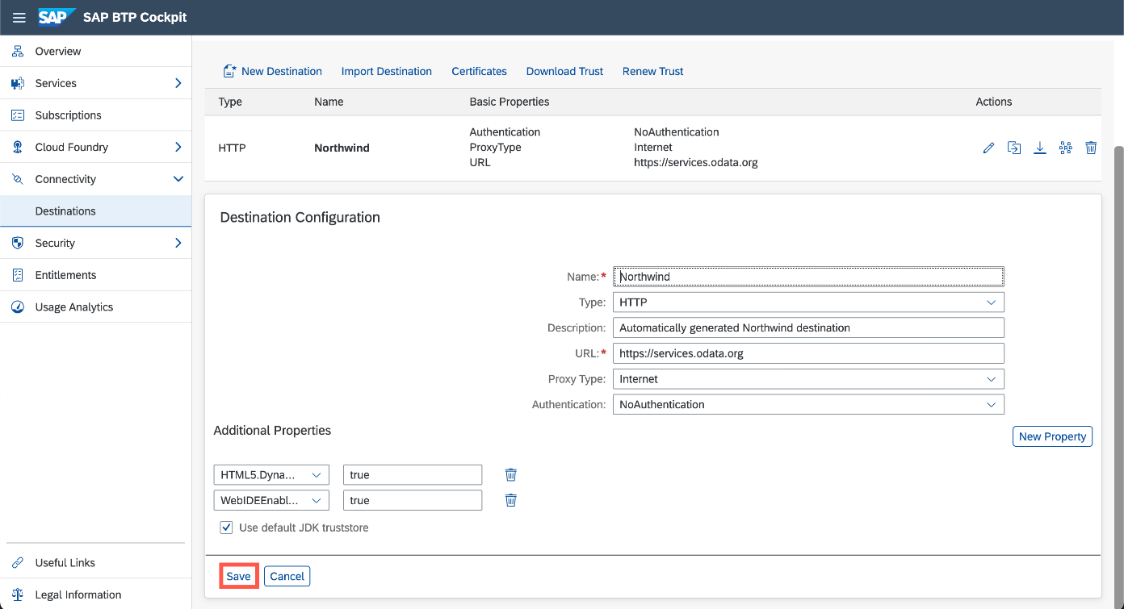

Step 5: Check the connection

Click on the Check Connection icon on the newly created Destination to see if everything works.

